Day 4 Assignment

Code:

#include<stdio.h>

char name[50];

char gender;

int age;

float salary;

void read(){

printf("Enter your full name: ");

fgets(name, 50, stdin);

printf("Enter gender: ");

scanf("%c", &gender);

printf("Enter age: ");

scanf("%d", &age);

printf("Enter Salary: ");

scanf("%f", &salary);

}

void display(){

printf("Name: %s ", name);

printf("Gender: %c\n ", gender);

printf("Age: %d\n ", age);

printf("Salary: %f\n ", salary);

}

int main(){

read();

display();

}

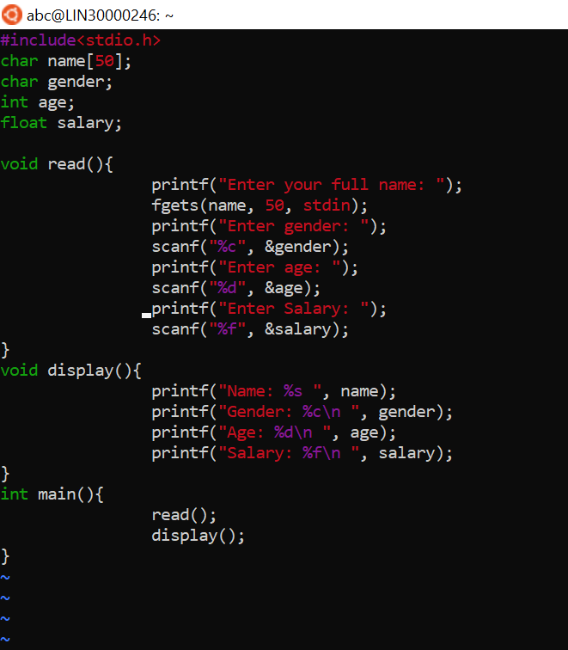

Output:

